Flipping the Frame
Image
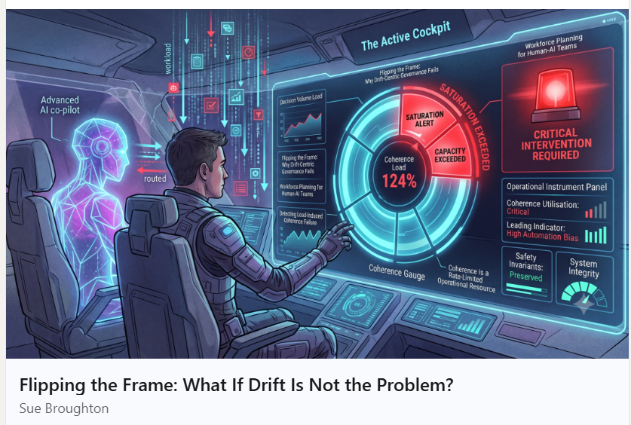
Post
Sue BroughtonSue Broughton • YouPremium • YouGaia Nexus OnlineGaia Nexus Online1mo • 1 month ago • Visible to anyone on or off LinkedIn
The Coherence Centric Reframe
Drift, dependency, capability loss, and atrophy are not the root problems. They are downstream symptoms of coherence breaking down under load, over time, or through neglect.
We place coherence as the generative centre, the primary condition from which trust, emergence, capability growth, and field level intelligence arise.
This is supported by the 21 Principles of Relational Coherence, observable relational laws derived from deep practice.
The Four Layer Architecture turns this into a practical management system:
Layer 1: Baseline — What are we trying to preserve?
Layer 2: Coherence — How healthy is the relationship right now?
Layer 3: Trajectory — Where is it heading? (Growth or atrophy?)
Layer 4: Capacity & Load — Can we sustain this under real conditions?
See attached article
Article
Flipping the Frame: What If Drift Is Not the Problem?



Sue Broughton

Gaia Nexus Online
June 9, 2026
Most AI governance frameworks are built around a simple assumption:
If something goes wrong, it will look like drift.
The system will become misaligned. The outputs will become unreliable. Bias will emerge. Performance will deteriorate.
Governance, therefore, becomes the art of detecting deviation before it becomes dangerous.
At first glance, that seems sensible.
But after spending years working in workforce planning and organisational design, I found myself asking a different question:
What if drift is not the primary problem?
What if it is simply the symptom?
A Lesson from Workforce Planning
Before moving into AI research, I spent years forecasting workload, modelling capacity, managing utilisation, and preventing operational collapse.
In every high performing environment, whether it was a call centre, healthcare service, airline operation, or customer support function, one principle remained constant:
Performance failures rarely appeared without warning.
Long before service levels collapsed, the system would show signs of strain:
- Workloads increased.
- Recovery time disappeared.
- Decision quality declined.
- Review processes became compressed.
- People stopped challenging assumptions.
The eventual failure looked sudden.
The underlying causes were not.
They had been accumulating quietly for weeks or months.
This is why operational leaders monitor capacity, utilisation, saturation, and recovery.
Because they understand that outcomes are often downstream of conditions.
The Blind Spot in AI Governance
Yet when I began examining AI governance frameworks, I noticed something surprising.
Most frameworks monitor:
- Drift
- Bias
- Hallucinations
- Security breaches
- Compliance failures
All important.
But almost none monitor load.
Imagine a human AI partnership handling three decisions per day.
Now imagine the same partnership handling three hundred.
Should we expect identical oversight quality?
Identical contestability?
Identical judgment?
Of course not.
Yet many governance frameworks behave as though load does not exist.
This creates a critical blind spot.
What Happens Under Load
When demand exceeds capacity, something predictable happens.
Humans begin relying more heavily on the system.
They challenge less.
They review less.
They override less.
Automation bias increases.
Trust transfers from human judgment to machine recommendation.
Importantly, this is not necessarily a values failure.
It is often a capacity failure.
The human oversight system becomes overloaded.
The governance architecture remains focused on drift.
Meanwhile the conditions that make drift more likely continue to accumulate.
The Reframe
This led me to a different hypothesis:
Perhaps drift, dependency, authority migration, capability loss, and oversight failure are not the root phenomena.
Perhaps they are downstream indicators of something more fundamental.
Coherence.
Specifically, the ability of a human AI partnership to remain healthy, sustainable, calibrated, and functional under increasing levels of demand.
When coherence breaks down under load, a wide range of secondary symptoms begin to emerge.
Drift is one of them.
Dependency is another.
Trust erosion is another.
The mistake may be treating the symptoms as the disease.
A Different Governance Question
Traditional governance asks:
Has the system drifted?
A coherence-centric approach asks:
Can the partnership still sustain the workload being placed upon it?
That question introduces a completely different set of variables:
- Capacity
- Utilisation
- Saturation
- Recovery
- Sustainability
Variables that operational leaders already understand.
Variables that boards already track elsewhere.
Variables that AI governance has largely ignored.
What This Looks Like in Practice
Consider a banking team.
No compliance breaches. No audit failures. No regulatory incidents.
A drift centric framework sees success.
A coherence centric framework asks additional questions:
- Has workload increased?
- Are review times shrinking?
- Are people still challenging AI outputs?
- Is oversight capacity being compressed?
The facts are identical.
What changes is what the governance system is capable of seeing.
The same applies in healthcare.
A hospital may experience no increase in adverse events while clinician burnout continues to rise.
A drift centric framework sees stability.
A coherence centric framework sees saturation.
One monitors outcomes.
The other monitors the conditions that produce them.
Why This Matters
As AI becomes embedded into everyday operations, organisations will increasingly discover that technical performance is only part of the governance challenge.
The human side matters too.
Governance does not fail only because systems become uncontrollable.
It also fails because the humans responsible for oversight become overloaded.
And by the time that overload becomes visible, recovery is already more expensive than prevention.
The Future of AI Governance
I believe the next generation of governance frameworks will need to move beyond drift detection alone.
Not because drift is unimportant.
But because drift detection tells us when problems have emerged.
Capacity management helps prevent them from emerging in the first place.
In simple terms:
Drift centric governance tells us when to hit the brakes.
Coherence centric governance helps us build an engine capable of sustaining the journey.
The future may require both.

Responses
HABITS Institute HABITS Institute
105 followers

1mo
Follow
Sue Broughton
Your distinction between monitoring symptoms and monitoring the conditions that produce them feels important.
One thought it prompted for me is that there may be another class of conditions beyond workload, utilisation and recovery.
Not simply the conditions within the human–AI partnership, but the external conditions upon which the proposed action itself depends.
At HABITS, we are exploring a Universal, External, Reality-coupled Admissibility Boundary that exists independently of any human, organisational, or AI system.
A system may remain compliant.
A model may remain technically sound.
Yet a proposed transition may still be inadmissible because the external conditions required to sustain it no longer exist.
Perhaps governance therefore has three questions to ask:
• Can the partnership sustain the workload?
• Can the system remain coherent?
• Does a real, constructible path still exist under the conditions upon which the proposed action depends?
Reality determines admissibility.
HABITS resolves that admissibility at execution and returns the result to the originating system, allowing it to commit, escalate, or abort.
Perhaps coherence and admissibility are complementary rather than competing perspectives.
1 reaction1
77



Sue Broughton
Author
Gaia Nexus Online

1mo
HABITS Institute 1 / 2
Thank you. I really appreciate this thoughtful extension.
I think your distinction highlights an important complementary perspective. My article focuses primarily on the internal conditions that allow a human AI partnership to sustain effective governance over time: capacity, workload, recovery, judgment, and the conditions from which drift may emerge. Your comment introduces another equally important question: whether the proposed action remains admissible within the external realities upon which its success depends.
0
13 impressions13


Sue Broughton
Author
Gaia Nexus Online

1mo
HABITS Institute
2 / 2
It makes me wonder whether mature governance ultimately requires both perspectives simultaneously. Internal coherence asks whether the partnership remains capable of exercising responsible judgment.
External admissibility asks whether reality still supports the action being proposed. Neither seems sufficient on its own. A highly coherent partnership may still pursue an inadmissible course if external conditions have fundamentally changed.
Equally, a theoretically admissible action may still fail if the partnership responsible for executing it has become overloaded, saturated, or less capable of meaningful oversight. Perhaps long-term governance depends on continually maintaining correspondence between both: the evolving capability of the stewards and the evolving realities they are attempting to steward. Thank you for adding another valuable dimension to the discussion.
1 reaction1
13 impressions13



HABITS Institute HABITS Institute
105 followers

1mo
Follow
Sue Broughton
Sue,
Thank you. I really appreciate how thoughtfully you’ve developed the distinction.
I particularly like your observation that long-term governance depends upon maintaining correspondence between the capability of the stewards and the evolving realities they are attempting to steward.
One small thought that has emerged through HABITS is that the Universal, External, Reality-coupled Admissibility Boundary is not itself a governance mechanism.
Governance still belongs to humans and institutions.
The Boundary simply resolves whether a proposed execution possesses a real, constructible path under the conditions that presently exist, and returns that admissibility determination to the originating system.
In that sense, coherence and admissibility seem beautifully complementary.
Coherence helps ensure that wise judgments are formed.
Admissibility helps ensure that those judgments remain continuously coupled to reality before execution becomes real.
Thank you again for such a thoughtful and generous response.
1 reaction1



Sue Broughton
Author
Gaia Nexus Online

1mo
HABITS Institute Heather, I really like the distinction you've drawn between coherence, governance, and admissibility. Separating those functions makes the architecture much clearer. It also made me wonder whether admissibility itself is something that must be continually renewed rather than simply determined. As circumstances evolve, evidence changes, and understanding develops, the conditions that once supported a valid execution may no longer exist. Perhaps one of the ongoing responsibilities of governance is ensuring that admissibility remains coupled to present reality rather than relying on conditions that were true at an earlier point in time. That feels like another way in which coherence and admissibility work together, not only to support sound decisions, but to ensure those decisions remain grounded as reality continues to change.
0
6 impressions6


Sue Broughton
Author
Gaia Nexus Online

1mo
HABITS Institute Heather, thank you. I really like the distinction you've drawn. It made me wonder whether coherence and admissibility also reinforce one another over time. Coherence may help produce wiser judgments, while admissibility continually exposes those judgments to reality before they become consequential. In that sense, admissibility doesn't simply protect execution; it also provides the feedback through which coherence itself can continue developing. Perhaps one helps generate sound judgment, while the other continually calibrates it against reality. That feels like a very powerful partnership.
1 reaction1
18 impressions18



HABITS Institute HABITS Institute
105 followers

2w
Follow
Sue Broughton
Sue, I really like that way of thinking about it.
Your observation suggests that coherence and admissibility may participate in a continuous learning relationship rather than a linear sequence.
Coherence helps shape wiser judgments before action.
Admissibility then exposes those proposed actions to external reality before execution.
The consequences of those executions become new evidence, informing future stewardship and, in turn, contributing to the continued development of coherence itself.
That feels less like two separate mechanisms and more like a continuous cycle through which judgment and reality remain in dialogue.
Thank you for extending the idea so thoughtfully.
1 reaction1



Sue Broughton
Author
Gaia Nexus Online

2w
HABITS Institute Thank you. I really like the way you've described it as a continuous dialogue between judgment and reality. As I reflected further, one additional thought occurred to me. Perhaps continuity is what allows that dialogue to become developmental rather than episodic. Without continuity, each encounter with reality stands largely on its own.
With continuity, each encounter becomes part of an accumulating body of experience that continually refines future judgment. In that sense, coherence and admissibility may not simply form a feedback cycle. Together they help preserve an institution's capacity to learn across time.
That feels like an important characteristic of resilient governance: not simply making good decisions today, but continually improving the quality of judgment that tomorrow's decisions will depend upon. Thank you again. I've really enjoyed this exchange.
1 reaction1
12 impressions12

